MySql Native Replication Setup Steps for a Container.

1. Create a container in a cluster using plain MySql image from the docker hub.
2. To setup the native replication between two clusters we must modify the MySql container configuration. We have done this using the ConfigMap (provided by Kubernetes to update a config of a container). Below is the config we updated
   1. Master Side:
      1. Config yml files are at <https://github.com/Abdul426/kubernetes>
      2. Modified config file and add server-id, logfile name
      3. Created a replication user with the required permissions
      4. 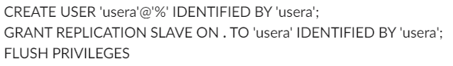
      5. More details can be found at <https://dev.mysql.com/doc/refman/5.6/en/replication-howto.html>
   2. Slave Side:
      1. Modify config file add server-id
      2. Joined with the master
      3. 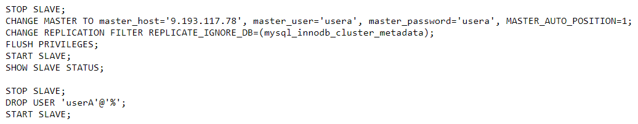
3. NFS:
   1. Created a VM as a NFS server
   2. Created pv, pvc and deployments accordingly.
   3. Yml can be found on the given github repo.